**Fr Kevin Horsell presents**

**Passion according to Luke**

**Sunday 30th March 2025**

**4.00pm – 5.00pm**

**and**

**Passion according to John**

**Sunday 6th April 2025**

**4.00pm – 5.00pm**

**at**

**Lefevre Meeting Rooms, 253 Military Road, Semaphore**

**Please bring a Bible and green parallels (if you already have them)**

**Notes will provided.**

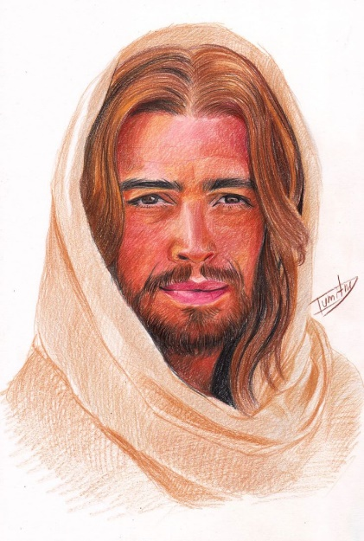

**Enquires to Bernadette Smith on**

**8449 6378**

**A Certificate of Attendance is available for professional development:**

**please register with Bernadette before the event, and on the day.**